

**Assignment Cover Sheet**

This sheet must be completed and attached to the assignment, **unless otherwise instructed. PLEASE PRINT**

|  |  |
| --- | --- |
| **Student ID** |  |
| **Student Name** |  |
| **Unit Code** |  |
| **Unit Name** |  |
| **Assignment Title** |  |
| **Lecturer’s Name** |  |
| **Class Time / Day** |  |
| **Assignment Due Date** |  |

# PLAGIARISM AND COLLUSION

* Plagiarism occurs when a student attempts to pass off as their own work, the work of another, without any acknowledgement as to its authorship or source.
* Collusion occurs when a student obtains the agreement of another person for a fraudulent purpose with the intent of obtaining an advantage in submitting an assignment or other work.
* A definition of plagiarism/collusion can be found in the Academic Integrity Policy located on the Student Portal. Deakin College may impose penalties in cases of plagiarism and/or collusion.

# DECLARATION

I certify that the attached work is entirely my own (or where submitted to meet the requirements of a group assignment is the work of the group), except where work quoted or paraphrased is acknowledged in the text. I also certify that it has not been submitted for assessment in any other unit or course.

**Student Signature**: **Date**:

**Please Note**: There are penalties for late submission of an assignment. Refer to your Unit Outline for more information.

Version: 5.8 I Document code: AD-LAT-158F

Page 1 of 1

Melbourne Institute of Business and Technology Pty Ltd trading as Deakin College; ABN 11 074 633 668; CRICOS Provider Codes: Deakin College 01590J, Deakin University 00113B





# Osmosis in plants

1. In the schematics below draw and label the cell and vacuole membranes as they appear in the different treatments. Include arrows to indicate water movement and pressures involved. Briefly describe what has occurred to the plant cells in the three solutions. (3 marks/drawing)







1. What did you observe after washing the plant that had been in the strong salt solution with a solution of in distilled water? (Full sentence, 1 mark)



# Osmosis in animal cells

1. What has happened to the cells in each solution? Explain the water movement in each case. Use a diagram to show the shape of the cell and indicating water movement (3 marks/drawing)



1. How do plant and animal cells differ in behaviour when placed in distilled water? What structural difference between plant and animals cells accounts for this observation? How do plants prevent their cells from bursting? (3 marks)





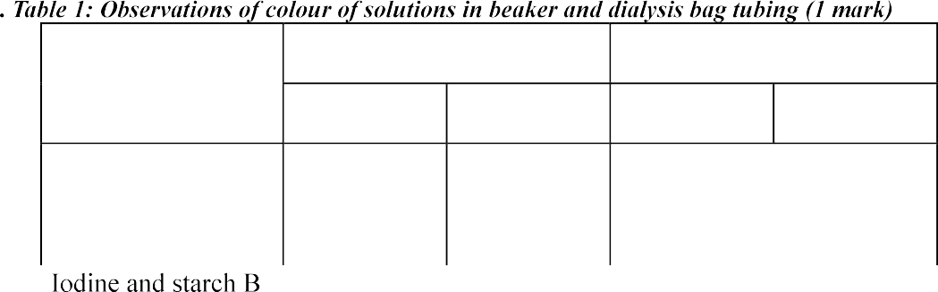

Test

Dialysis bag solution colour

Start finish

Iodine and Starch A

|  |  |  |  |
| --- | --- | --- | --- |
|  |  |  |  |
| Neutral Red and NaOH A |  |  |  |
| Neutral Red and NaOH B |  |  |  |

Answer the following questions about the results of this experiment.

1. From the results of your experiment which substances appear to be able to pass through the dialysis tubing and which cannot? (1 marks)
2. If we were to only consider the results of the experiment just completed what would we say determines if a substance can cross the phospholipid bilayer (1 mark)
3. What is the purpose of running the experiments above in the A and B treatments (1 mark)?
4. In this prac we used dialysis tubing to represent the phospholipid bilayer but what are the limitations of using dialysis tubing to represent the phospholipid bilayer 

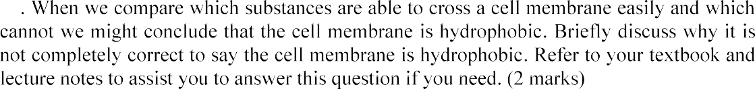



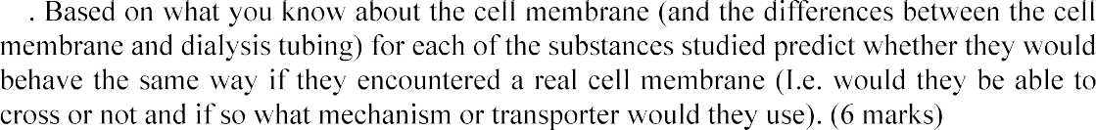





**End of prac: Be sure wash your dishes & clean your workstation before leaving the laboratory**